Story Stretchers:
Tall and Funny Tales
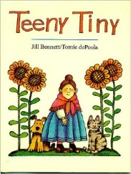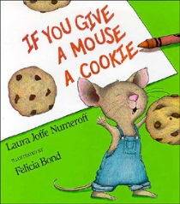
Lesson Plan
July 17th- July 21st
Classroom: Young Toddler
Week 7 Topic: Teeny Tiny & If You Give a Mouse a Cookie
 |  | Monday | Tuesday | Wednesday | Thursday | Friday
Circle Time |  | Daily Calendar  Book: Teeny Tiny | Daily Calendar  Book: Teeny Tiny | Daily Calendar  Book: Green Eggs and Ham | Daily Calendar  Book: If You Give a Mouse a Cookie | Daily Calendar  Book: If You Give a Mouse a Cookie
Creative Arts |  | Read “Teeny Tiny” then Paint a ghost | Tissue paper sunflower | Paper plate green eggs and ham | Make a mouse using triangle and circles | M is for Mouse (decorating the letter M)
Music & Movement |  | Sing the “Teeny Tiny Spider” song | Five little monkey’s jumping on the bed | Special Music and Movement with Ms. Stelly | C is for Cookie: the Cookie monster dance | Listen and Move: freeze dance song
Outdoor Activity |  | Crawling like Teeny Tiny animals | Bubble Day | Nature Walk | Cookie Hunt | Water Play
 | Math & Science | Cooking:  Little Nibbles (Pretzel Sticks, Cereal, Raisins, Sunflower seeds)
 | Sensory | Colored Rice, Pouring/ Scooping Utensils, Scales
 | Dramatic Play | Baking Cookies in the Home Center
 | Special Activities | Monday: Obstacle course on playground for crawling  Tuesday: Bubble Day  Wednesday: Music w/ Ms. Stelly  Thursday: Spirit Day  Friday: Water Day

