Story Stretchers: Classic Stories
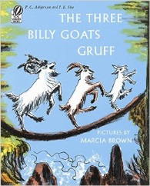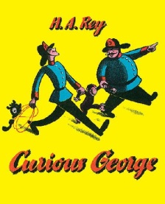
July 10th- July 14th
Classroom: Toddler I
Teachers: Ms.Munoz
Week 6 Topic: The Three Billy Goats Gruff & Curious George
 |  | Monday | Tuesday | Wednesday | Thursday | Friday
Circle Time |  | Daily Calendar  Book: The Three Billy Goats Gruff | Daily Calendar  Book: The Three Billy Goats Gruff | Daily Calendar  Book: Curious George | Daily Calendar  Book: Curious George | Daily Calendar  Book: Curious George
Creative Arts |  | Paper Plate Goat | Make a Pet Troll Using Molding Clay | Special Art w/ Ms. Stelly | Paper Plate Monkey Craft | Glue Yellow Tissue Paper Onto a Banana
Music & Movement |  | Three Billy Goats Song- See attachment | “Down on ______ Farm”- Let each child choose an animal | 5 Little Monkeys Jumping on the Bed | 5 Little Monkeys Swinging on the Tree | Monkey See, Monkey Do Movement Song
Outdoor Activity |  | Bubbles and Chalk | Special Guest:  Soccer Shots | Nature Walk | Build a Bridge with Waffle Blocks on Playground | Water Play
 | Math & Science | Cooking:  Banana Treats (Bananas, Granola, Raisins, Honey)
 | Sensory | Zoo Animals, Branches, Safari Items
 | Dramatic Play | Toddlers dress in safari and camo; go on a nature hunt
 | Special Activities | Tuesday: Soccer Shots  Wednesday: Art w/ Ms. Stelly  Friday: Water Day  Everyday: Gym and Thursdays w/ Ms. McIvor or Ms. Eggers

