Story Stretchers:
Tall and Funny Tales
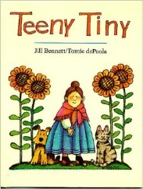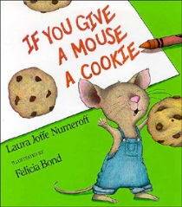
Lesson Plan
July 17th- July 21st
Teachers: Ms. Munoz
Week 7 Topic: Teeny Tiny & If You Give a Mouse a Cookie
 | Monday | Tuesday | Wednesday | Thursday | Friday
Circle Time | Daily Calendar  Book: Teeny Tiny | Daily Calendar  Book: Teeny Tiny | Daily Calendar  Book: Green Eggs and Ham | Daily Calendar  Book: If You Give a Mouse a Cookie | Daily Calendar  Book: If You Give a Mouse a Cookie
Creative Arts | Build a teeny tiny house (pipe cleaners) | Hand painting/stamping | Green and yellow slime | Paper bag mouse craft | Cookie decorating with play dough
Music & Movement | Simon Says | Hokey Pokey | Special Music and Movement with Ms. Stelly | Old McDonald with puppets | Wood and steel instruments
Outdoor Activity | Chalk and Bubbles | Special Guest:  Soccer Shots | Nature Walk | Field Day | Water Play
Math & Science | Cooking:  Little Nibbles (Pretzel Sticks, Cereal, Raisins, Sunflower seeds)
Sensory | Colored Rice, Pouring/ Scooping Utensils, Scales
Dramatic Play | Bakery: Toddlers use pans and baking utensils to bake and cook deserts  Have a desert party!
Special Activities | Monday:  Tuesday: Soccer Shots  Wednesday: Music w/ Ms. Stelly  Friday: Water Day  Everyday: Gym

