Story Stretchers: Classic Stories
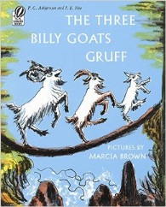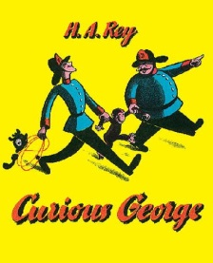
Lesson Plan
July 10th- July 14th
Ms. Dalcour and Ms. Martinez
Classroom: Toddler 2
Week 6 Topic: The Three Billy Goats Gruff & Curious George
 |  | Monday | Tuesday | Wednesday | Thursday | Friday
Circle Time |  | Daily Calendar  Book: The Three Billy Goats Gruff | Daily Calendar  Book: The Three Billy Goats Gruff | Daily Calendar  Book: Runaway Bunny | Daily Calendar  Book: Curious George | Daily Calendar  Book: Curious George
Creative Arts |  | Paper plate goat | Billy goat silhouette painting | Special Art w/ Ms. Stelly | Handprint monkey | Tissue paper banana
Music & Movement |  | “Hungry Billy Goats Gruff” song | “The green grass grows all around” song | “Ten little bunnies”  song | “Five little monkeys jumping on a bed” song | “Five little monkeys swinging from a tree” song
Outdoor Activity |  | “Monkey see, Monkey do”  copycat game | Special Guest:  Soccer Shots | Nature Walk | Bubbles on back patio | Water Play
 | Math & Science | Cooking:  Banana Treats (Bananas, Granola, Raisins, Honey)
 | Sensory | Zoo Animals, Branches, Safari Items
 | Dramatic Play | Chef’s choice: cook a special treat for the animals we’ve learned about this week
 | Special Activities | Monday:  Tuesday: Soccer Shots  Wednesday: Art w/ Ms. Stelly  Thursday: Bubbles on the back patio  Friday: Water Day  Everyday: Gym and Thursdays w/ Ms. McIvor or Ms. Eggers

