Story Stretchers: Classic Stories
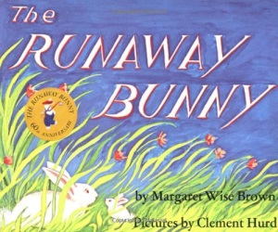
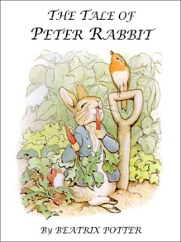
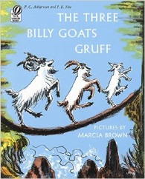

Lesson Plan
July 10th- July 14th
Classroom: Preschool
Week 6 Topic: The Three Billy Goats Gruff, The Tale of Peter Rabbit & The Runaway Bunny

 |  | Monday | Tuesday | Wednesday | Thursday | Friday
Circle Time |  | Who are an Author & Illustrator  Book: The Three Billy Goats Gruff | Which Animals are in your favorite story?  Book: The Three Billy Goats Gruff | What happens to animals in a story?  Book:The Tail of Peter Rabbit | Where can a story take place?  Book: The Tail of Peter Rabbit | Can a Story be Real or Pretend?  Book: The Runaway Bunny
Creative Arts |  | Shaving Cream Paint a Billy Goat | Glue Fluffy Items on a Rabbit | Special Art  w/ Ms. Stelly | Print Paint with  Veggie Pieces | Watercolor  Painting
Music & Movement |  | Trip, Trap Music w/Instruments | Bean Bag Music & Movement | The Bunny Hop | Instrument Play:  Fast & Slow | Move with Ribbon Wands
Outdoor Activity |  | Run & Jump like Billy Goats | Special Guest:  Soccer Shots  Parachute Play | Find the Carrots & Feed the Rabbit | Peter Rabbit’s Veggie Tag | Water Play  Parachute Play
 | Math & Science | Cooking:  Banana Treats (Bananas, Granola, Raisins, Honey)/Make Homemade Carrot Muffins
 | Sensory | Farm Animals, Branches, Rocks, Leaves
 | Dramatic Play | Puppets: The Three Billy Goats Story/Play & Pretend: Bunny Headbands
 | Special Activities | 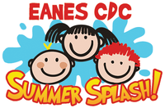  Tuesday: Soccer Shots  Wednesday: Art w/ Ms. Stelly  Thursday: Cooking Day  Friday: Water Day  Everyday: Gym

