Story Stretchers: Classic Stories
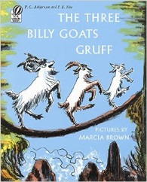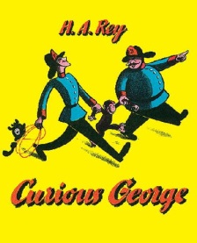
Lesson Plan
July 10th- July 14th
Classroom: Young Toddler
Week 6 Topic: The Three Billy Goats Gruff & Curious George
 |  | Monday | Tuesday | Wednesday | Thursday | Friday
Circle Time |  | Daily Calendar  Book: The Three Billy Goats Gruff | Daily Calendar  Book: The Three Billy Goats Gruff | Daily Calendar  Book: Children’s Choice- Kids pick out of library | Daily Calendar  Book: Curious George | Daily Calendar  Book: Curious George
Creative Arts |  | Paper Plate Billy Goat Craft | G is for Goat (decorating the letter G) | Special Art w/ Ms. Stelly | Yellow hat painting | Paper plate Curious George Craft
Music & Movement |  | Sing “Billy Goats Gruff” | Sing “Trip Trap” the Troll Song | Listen to Billy Goats Song and dance | “The Friendship Song” by Curious George | “Go Bananas” listen and move
Outdoor Activity |  | Billy Goat Racing | Bubbles | Nature Walk | Crossing the Bridge  (while on  our walk) | Water Play
 | Math & Science | Cooking:  Banana Treats (Bananas, Granola, Raisins, Honey)
 | Sensory | Zoo Animals, Branches, Safari Items
 | Dramatic Play | Add blocks and blue tissue paper to dramatic play center. Children can make bridges for the Billy Goats and act out the book.
 | Special Activities | 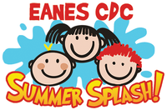  Monday: Go Bananas Dance Party  Tuesday: Bubble Day  Wednesday: Art w/ Ms. Stelly  Thursday: Spirit Day  Friday: Water Day

