Story Stretchers: Classic Stories
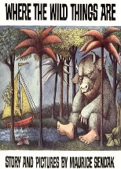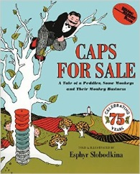
Lesson Plan
June 26th- June 30th
Classroom:
Week 5: Topic: Where the Wild Things Are & Caps for Sale
 |  | Monday | Tuesday | Wednesday | Thursday | Friday
Circle Time |  | Daily Calendar  Book: Where the Wild Things Are | Daily Calendar  Book: Where the Wild Things Are | Daily Calendar  Book: Runaway Bunny | Daily Calendar  Book: The Three Billy Goats Gruff | Daily Calendar  Book: The Three Billy Goats Gruff
Creative Arts |  | Put Dots  On Max | Wild Things  Ear Collage | Cotton Ball  Bunny | Billy Goat  Hoove Print | Paint white  On grey paper
Music & Movement |  | Let The Wild Rumpus Starts | More Wild Thing  Stomping | Special Music and Movement with Ms. Stelly | Jump like  A Goat | Stomp like  A troll
Outdoor Activity |  | Looking For Animals | Special Guest:  Soccer Shots | Nature Walk | Bubble  Day | Water Play
 | Math & Science | Cooking:  Animal Crackers, Frosting, Sprinkles
 | Sensory | Blocks to build bridges
 | Dramatic Play | Hats On Home Center
 | Special Activities | 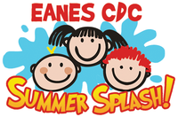  Monday: Yoga Fun  Tuesday: Dance Party  Wednesday: Music w/ Ms. Stelly  Thursday: Bubble Day  Friday: Water Day  Everyday: Gym and Thursdays w/ Ms. McIvor or Ms. Eggers

