Story Stretchers: Classic Stories
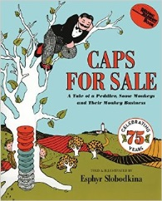
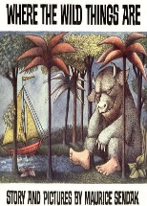
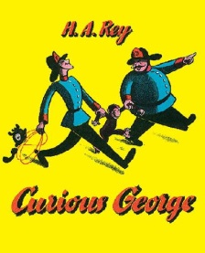

Lesson Plan
June 26th- June 30th
Classroom:
Week 5 Topic: Where the Wild Things Are & Caps for Sale
 |  | Monday | Tuesday | Wednesday | Thursday | Friday
Circle Time |  | Do you like to listen to books & why?  Book: Where the Wild Things Are | Where do you like to listen to books?  Book: Where the Wild Things Are | Who reads books to you?  Book: Curious George | What kinds of stories are you favorites?  Book: Caps for Sale | Let’s Make a Story of Our Own  Book: Caps for Sale
Creative Arts |  | Sailboat Painting | Wild Thing  Mask | Monkeys  on a Tree | Handprint Hanging Monkey | Wild & Silly  Collage
Music & Movement |  | Wild Move & Freeze Dance | Wild Rumpus  March & Dance | Special Music and Movement with Ms. Stelly | Animals In Action  Animal Exercise | Monkey in the Middle  I Like to Move It
Outdoor Activity |  | What time is it Mr. Crocodile? | Special Guest:  Soccer Shots | Hide and Seek  Monkeys | How Many Monkeys Can You Find? | Splash Time
 | Math & Science | Cooking:  Animal Crackers, Frosting, Sprinkles/Make Homemade Monkey Bread
 | Sensory | Water Play with Boats and Animals
 | Dramatic Play | Play with Hats/Caps & Monkeys/All Aboard Our Sailboat
 | Special Activities | 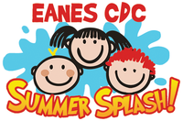  Tuesday: Soccer Shots  Wednesday: Music w/ Ms. Stelly  Thursday: Cooking  Friday: Water Day  Everyday: Gym (afternoon)

