Story Stretchers: Bears
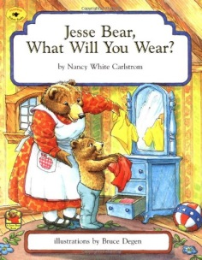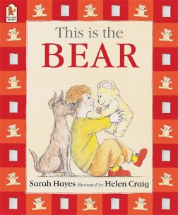
June 19th- June 23rd
Mrs. Pierre & Mrs. Miller
Classroom: Toddler I
Week 4 Topic: Jesse Bear, What Will You Wear? & This is Bear
 |  | Monday | Tuesday | Wednesday | Thursday | Friday
Circle Time |  | Daily Calendar  Book: Jesse Bear, What Will You Wear? | Daily Calendar  Book: Jesse Bear, What Will You Wear? | Daily Calendar  Book: This is Bear | Daily Calendar  Book: This is Bear | Daily Calendar  Book: This is Bear
Creative Arts |  | Dot Marker Butterfly | Color Different Pieces of Clothing | Special Art w/ Ms. Stelly | Letter B for Bear Gluing Activity | Decorate Shoes to Put on Jesse Bear
Music & Movement |  | 5 Little Bears (Counting Up Song) | 5 Little Bears (Counting Down Song) | The Bear Song (See Attachment) | “Walky Round the Garden” Song via YouTube | Going on a Bear Hunt
Outdoor Activity |  | Water Bottle Spray Tag | Special Guest:  Soccer Shots | Nature Walk | Toy Wash- Take bucket of water and clothes to “wash the toys” | Water Play
 | Math & Science | Cooking:  Ants on a Log (Celery, Cream cheese, raisins)
 | Sensory | Teddy Bear Dressing Station: Bears and clothing OR  Teddy Bear Picnic Items (Setting up for a Picnic)
 | Dramatic Play | Bear Hunt- Provide children with various items from a Bear Hunt song by Dr. Jean so they may pretend like they are going on a bear hunt
 | Special Activities | Tuesday: Soccer Shots  Wednesday: Art w/ Ms. Stelly  Friday: Water Day  Every day: Gym and Thursdays w/ Ms. McIvor or Ms. Eggers

The Bear

Here is a cave, (make a fist)
Inside is a bear. (put a thumb inside fist)
Now he comes out
To get some fresh air. (pop out thumb)
He stays out all summer
In sunshine and heat.
He hunts in the forest
For berries to eat. (move thumb in circle)
When snow starts to fall,
He hurries inside
His warm little cave,
And there he will hide. (put thumb back inside fist)
Snow covers the cave
Like a fluffy white rug.
Inside the bear sleeps
All cozy and snug. (cover fist with other hand)

