Story Stretchers: Bears
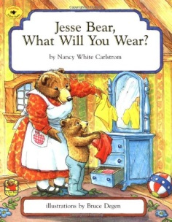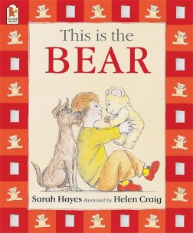
Lesson Plan
Ms. Dalcour and Ms. Munoz
June 19th- June 23rd
Classroom: Toddler 2
Week 4 Topic: Jesse Bear, What Will You Wear? & This is Bear
 |  | Monday | Tuesday | Wednesday | Thursday | Friday
Circle Time |  | Daily Calendar  Book: Jesse Bear, What Will You Wear? | Daily Calendar  Book: Jesse Bear, What Will You Wear? | Daily Calendar  Book: The teddy Bears Picnic | Daily Calendar  Book: This is Bear | Daily Calendar  Book: This is Bear
Creative Arts |  | Coloring clothes for Jesse Bear | “B” is for bear craft | Special Art w/ Ms. Stelly | Paw prints | Shaving cream animals
Music & Movement |  | Move to the music dance party | “5 little bears” song | “Hot Bear”  Hot potato game | “The bear went over the mountain” song | “Teddy bear, teddy bear” song
Outdoor Activity |  | Hula hoop fun | Special Guest:  Soccer Shots | Nature Walk | Riding bikes on back patio | Water Play
 | Math & Science | Cooking:  Ants on a Log (Celery, Cream cheese, raisins)
 | Sensory | Teddy Bear Dressing Station: Bears and clothing OR  Teddy Bear Picnic Items (Setting up for a Picnic)
 | Dramatic Play | What will you wear? – have various clothes set out for the children to dress themselves for the day
 | Special Activities | Monday:  Tuesday: Soccer Shots  Wednesday: Art w/ Ms. Stelly  Thursday: Riding bikes on the back patio  Friday: Water Day  Everyday: Gym and Thursdays w/ Ms. McIvor or Ms. Eggers

