Story Stretchers: Bears
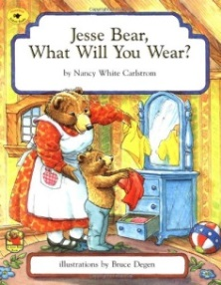
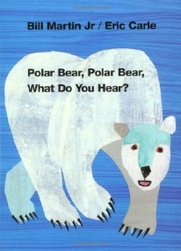
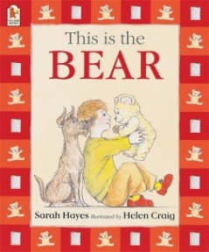

Lesson Plan
June 19th- June 23rd
Classroom: Preschool
Week 4 Topic: Jesse Bear, What Will You Wear? Polar Bear, Polar Bear & This is Bear
 | Monday | Tuesday | Wednesday | Thursday | Friday
Circle Time | Book: Jesse Bear, What Will You Wear? | Book: Jesse Bear, What Will You Wear? | Polar Bear, Polar Bear, What Do You Hear?  : | Book: This is Bear | Book: This is Bear
Creative  Arts | Stencil Bear  Painting | String  Painting Art | Special Art  w/ Ms. Stelly | Paint a Hairy  Polar Bear | Dot Art Print Painting
Music & Movement | Teddy Bear, Teddy Bear | Sticky, Sticky Bubble Gum | Dancing & Moving  w/Ribbons | Move Your Bears Here & There | Late Last Night  Yoga Fun
Outdoor Activity | Colored Bears  Game | Special Guest:  Soccer Shots | Hide & Seek Bears | What Time is it Mr. Bear? | Water Play
Math & Science | Cooking:  Bears on a Log (Celery, Cream cheese, raisins)
Sensory | Bear Play with water & rocks
Dramatic Play | Teddy Bear Dressing Station  Teddy Bear Picnic Items (Setting up for a Picnic)
Special Activities | 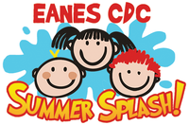  Tuesday: Soccer Shots  Wednesday: Art w/ Ms. Stelly  Thursday: Cooking  Friday: Water Day  Everyday: Gym (in the afternoon)

