Story Stretchers: Bears
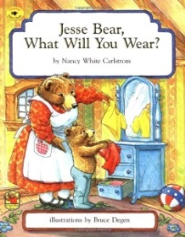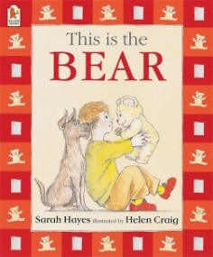
Lesson Plan
June 19th- June 23rd
Classroom: Pre-K
Week 4 Topic: Jesse Bear, What Will You Wear? & This is Bear
 |  | Monday | Tuesday | Wednesday | Thursday | Friday
Circle Time |  | Daily Calendar  Book: Jesse Bear, What Will You Wear? | Daily Calendar  Book: Jesse Bear, What Will You Wear? | Daily Calendar  Book: Brown Bear  What do you see? | Daily Calendar  Book:  This is Bear | Daily Calendar  Book:  This is Bear
Creative Arts |  | Cut and Paste  Paper Bag Bear | Corn Meal “Sand”Dough | Special Art  w/ Ms. Stelly | Brown Bear  Slime | Animal Footprints
Music & Movement |  | Movement:  The Freeze Game | Game: Simon Says | Paper Planes on  Field | Hopscotch | Movement:  Listen and Move
Outdoor Activity |  | Basketballs on  Court | Special Guest:  Soccer Shots | Nature Walk | Bikes on Basketball Court | Water Play
 | Math & Science | Cooking:  Ants on a Log (Celery, Cream cheese, raisins)
 | Sensory | Teddy Bear Dressing Station: Bears and clothing OR  Teddy Bear Picnic Items (Setting up for a Picnic)
 | Dramatic Play | Children pretend to have a picnic outside with stuffed animals.
 | Special Activities | Monday:  Tuesday: Soccer Shots  Wednesday: Art w/ Ms. Stelly  Thursday: Cooking  Friday: Water Day  Everyday: Gym and Thursdays w/ Ms. McIvor or Ms. Eggers

