Story Stretchers: Bears
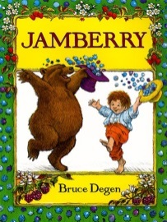
June 12th- June 16th
Ms. Martinez & Ms. Riddley
Classroom: Toddler I
Week 3 Topic: Corduroy & Jamberry
 |  | Monday | Tuesday | Wednesday | Thursday | Friday
Circle Time |  | Daily Calendar  Book: Corduroy | Daily Calendar  Book: Corduroy | Daily Calendar  Book: Corduroy | Daily Calendar  Book: Jamberry | Daily Calendar  Book: Jamberry
Creative Arts |  | Build a Corduroy Gluing Activity | Corduroy Paper Plate Craft | Glue Button Names to Construction Paper | Glue Black “Seeds” to a Strawberry | Handprint Strawberry
Music & Movement |  | “We’re Going on a Bear Hunt” | “The Bear Went Over the Mountain” | Special Music and Movement with Ms. Stelly | “Teddy Bear, Teddy Bear’ Turn Around” | “Five Little Bears” Finger Play
Outdoor Activity |  | Find hidden plastic bears on playground | Special Guest:  Soccer Shots | Nature Walk | Bear Crawl Races | Water Play
 | Math & Science | Cooking:  Tasting Berries- Strawberries, blueberries, blackberries
 | Sensory | Buttons, yarn and plastic needles, felt
 | Dramatic Play | Bears Den- Provide the children with sleeping mats for them to pretend to hibernate on
 | Special Activities | Monday:  Tuesday: Soccer Shots  Wednesday: Music w/ Ms. Stelly  Thursday: Field Day  Friday: Water Day  Everyday: Gym and Thursdays w/ Ms. McIvor or Ms. Eggers

