Story Stretchers: Bears
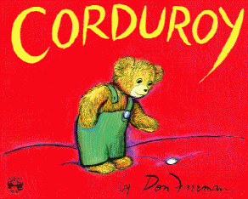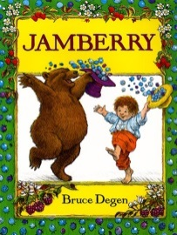
Lesson Plan
June 12th- June 16th
Classroom: Infant
Week 3 Topic: Corduroy & Jamberry
 |  | Monday | Tuesday | Wednesday | Thursday | Friday
Circle Time |  | Song: Good Morning Song  Book: Corduroy | Song: Good Morning Song  Book: Corduroy | Song: Good Morning Song  Book: Jamberry | Song: Good Morning Song  Book: Jamberry | Song: Good Morning Song  Book: Jamberry
Creative Arts |  | Color a bear with brown paint | Sponge painting | Purple bubbles | Bear Feet Art | Finger painting with purple painting
Music & Movement |  | Infants reach out to toy & show their Likes/ dislikes | Respond to new face | Special Music and Movement with Ms. Stelly | Make sounds in response to music | Mirror pull ups to strengthen arm & motor skills
Outdoor Activity |  | Purple shaving cream | Special Guest:  Soccer Shots | Nature Walk | Sensory bag | Water Play
 | Math & Science | Purple Jell-O in a bag
 | Sensory | Big Buttons, Yarn , felt
 | Dramatic Play | Infants imitate simple play in kitchen center
 | Special Activities | Monday: Buggy Walk  Tuesday: Soccer Shots  Wednesday: Music w/ Ms. Stelly  Thursday: Gym  Friday: Water Day  Everyday: Gym and Thursdays w/ Ms. McIvor or Ms. Eggers

