Story Stretchers: Bears
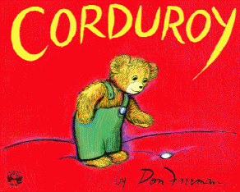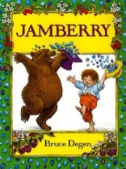
Lesson Plan
June 12th- June 16th
Classroom: Pre-K
Week 3 Topic: Corduroy & Jamberry
 |  | Monday | Tuesday | Wednesday | Thursday | Friday
Circle Time |  | Daily Calendar  Book: Corduroy | Daily Calendar  Book: Corduroy | Daily Calendar  Book: Three Bears | Daily Calendar  Book: Jamberry | Daily Calendar  Book: Jamberry
Creative Arts |  | Fork painting with brown | Paper Plate  Corduroy | Building a “100” cup structure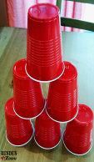 | No- Cook 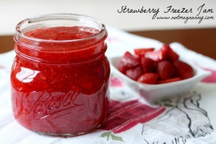Strawberry Freezer Jam | Stamp Painting with  Berry Baskets
Music & Movement |  | Bear Walk  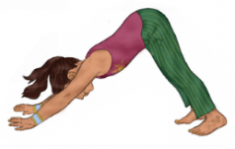 | Lego card game | Special Music and Movement with Ms. Stelly | Brown Bear  What do you see?  Movement game. | Children pretend to dance in the strawberry meadows with red steamers
Outdoor Activity |  | Hula Hoop Obstacle Course | Special Guest:  Soccer Shots | Nature Walk | Going on a Bear Hunt | Water Play
 | Math & Science | Cooking:  Tasting Berries- Strawberries, blueberries, blackberries
 | Sensory | Buttons, Yarn and plastic needles, felt
 | Dramatic Play | Children are enjoyed to play and pretend at the Grocery Store
 | Special Activities | Monday:  Tuesday: Soccer Shots  Wednesday: Music w/ Ms. Stelly  Thursday: Cooking  Friday: Water Day  Everyday: Gym and Thursdays w/ Ms. McIvor or Ms. Eggers

