Story Stretchers: Bears
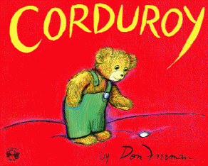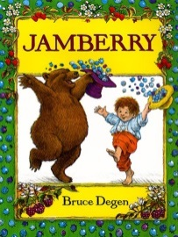
Lesson Plan
June 12th- June 16th
Classroom:
Week 3 Topic: Corduroy & Jamberry Ms, Murrey and Ms, Campos
 |  | Monday | Tuesday | Wednesday | Thursday | Friday
Circle Time |  | Daily Calendar  Book: Corduroy | Daily Calendar  Book: Corduroy | Daily Calendar  Book: Paddington | Daily Calendar  Book: Jamberry | Daily Calendar  Book: Jamberry
Creative Arts |  | Corduroy  Buttons  Collage | Painting  Corduroy | Painting  Paddington’s  Coat | Paint  With  Berry Basket | Put Dots  On  Strawberry
Music & Movement |  | Jumping | Teddy Bear  Teddy Bear | Special Music and Movement with Ms. Stelly | Dancing in  The meadow | Bubble  Dance
Outdoor Activity |  | Take turns sending Corduroy Bear down the slide | Special Guest:  Soccer Shots | Nature Walk | Bubbles | Water Play
 | Math & Science | Cooking:  Tasting Berries- Strawberries, blueberries, blackberries
 | Sensory | Buttons, Yarn and plastic needles, felt
 | Dramatic Play | Dressing Winnie the Poo
 | Special Activities | Monday:  Tuesday: Soccer Shots  Wednesday: Music w/ Ms. Stelly  Thursday: Bubble Day  Friday: Water Day  Everyday: Gym and Thursdays w/ Ms. McIvor or Ms. Eggers

