Story Stretchers: Friendship
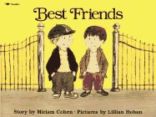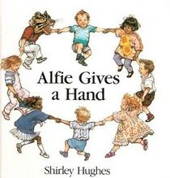
Lesson Plan
June 5th- June 9th
Classroom: Young Toddler
Week 2 :Topic: Best Friends & Alfie Gives a Hand- Ms,Murray and Ms,Campos
 |  | Monday | Tuesday | Wednesday | Thursday | Friday
Circle Time |  | Daily Calendar  Book: Best Friends | Daily Calendar  Book: Best Friends | Daily Calendar  Book: Red is Best | Daily Calendar  Book: Alfie Gives a Hand | Daily Calendar  Book: Alfie Gives a Hand
Creative Arts |  | Friendship  Stamp’s | Friendship  Collage | Special Art w/ Ms. Stelly | Water  Color | Color  A  Rainbow
Music & Movement |  | Song:  Good Morning  Friends | Song:  Make New  Friends | Song:  Friendship  song | Song:  Five  Friends | Song:  Good Bye  Friends
Outdoor Activity |  | Playing together | Special Guest:  Soccer Shots | Nature Walk | Bubbles | Water Play
 | Math & Science | Cooking:  Friendship Fruit Salad- Everyone Bring a piece of fruit
 | Sensory | Recycled Items, Bubbles and Water
 | Dramatic Play | Friendship Dress up
 | Special Activities | 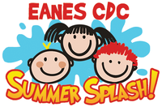  Monday:  Tuesday: Soccer Shots  Wednesday: Art w/ Ms. Stelly  Thursday: Field Day  Friday: Water Day  Everyday: Gym and Thursdays w/ Ms. McIvor or Ms. Eggers

