Story Stretchers: Friendship
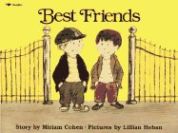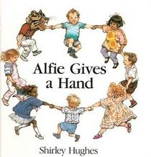
Lesson Plan
June 5th- June 9th
Classroom: Preschool
Week 2 Topic: Little Quack’s New Friend, Fox Makes Friends & Alfie Gives a Hand
 |  | Monday | Tuesday | Wednesday | Thursday | Friday
Circle Time  Calendar  Theme  Weather  Story  Song |  | How can you make a new friend?  Book: Little Quack’s New Friend | What do friends talk about?  Book: Fox Makes Friends | What do friends share with each other?  Book: Fox Makes Friends | How do friends work out a problem?  Book: Alfie Gives a Hand | How do friends help each other?  Book: Alfie Gives a Hand
Creative Arts |  | Marble Painting  Pond Collage | Shaving Cream Finger Painting  Make Egg Shakers | Special Art  w/ Ms. Stelly | Balloon  Painting | Paper Bag Puppet
Music & Movement |  | Shake, Rattle & Rock  Instrument Play | The Boogie Walk  Egg Shakers | Popcorn  Ribbon Wands | Sticky Bubble Gum  March, Skip, Hop | Clap, Clap, Clap  Rhythm Sticks
Outdoor Activity |  | Jumping Friends  In/Out of Hoops | Special Guest:  Soccer Shots  The Old Grey Cat is Sleeping Game | Nature Walk  Pairs of Friends  Find Objects | Field Day  Ball Play | Water Play  Bubbles & Chalk
 | Math & Science | Cooking:  Friendship Fruit Salad- Everyone Bring a piece of fruit
 | Sensory | Bubbles and Water
 | Dramatic Play | Friends at a Birthday Party
 | Special Activities | 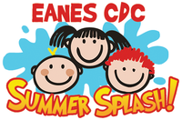  Monday: Bicycle Racing  Tuesday: Soccer Shots  Wednesday: Art w/ Ms. Stelly  Friday: Water Day  Everyday: Gym and Thursdays w/ Ms. McIvor or Ms. Eggers

