Story Stretchers: Friendship
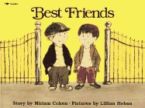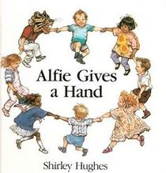
Lesson Plan
June 5th- June 9th
Classroom: Pre-K
Week 2 Topic: Best Friends & Alfie Gives a Hand
 |  | Monday | Tuesday | Wednesday | Thursday | Friday
Circle Time |  | Daily Calendar  Book: Best Friends | Daily Calendar  Book: Best Friends | Daily Calendar  Book: Red is Best | Daily Calendar  Book: Alfie Gives a Hand | Daily Calendar  Book: Alfie Gives a Hand
Creative Arts |  | Watercolors | Finger paint Designs | Special Art  w/ Ms. Stelly | Balloon Painting | Puff Painting
Music & Movement |  | Yoga Poses | “Go Noodle”  Movement Game | Do you want to be my friend with puppets | Balloons and Music | Song:  Tooty Ta
Outdoor Activity |  | Waffle Block Building | Special Guest:  Soccer Shots | Nature Walk | Bikes on Court | Water Play
 | Math & Science | Cooking:  Friendship Fruit Salad-  Everyone Bring a piece of fruit
 | Sensory | Recycled Items, Bubbles and Water
 | Dramatic Play | Children pretend to celebrate friend’s birthday.
 | Special Activities | 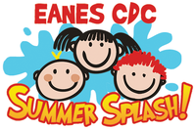  Monday:  Tuesday: Soccer Shots  Wednesday: Art w/ Ms. Stelly  Thursday: Field Day  Friday: Water Day  Everyday: Gym and Thursdays w/ Ms. McIvor or Ms. Eggers

