Story Stretchers: Friendship
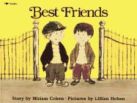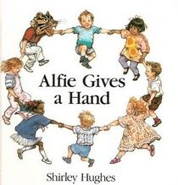
Lesson Plan
June 5th- June 9th
Classroom: Infant
Week 2 Topic: Best Friends & Alfie Gives a Hand
 |  | Monday | Tuesday | Wednesday | Thursday | Friday
Circle Time |  | Song: Good Morning Song  Book: Best Friends | Song: Good Morning Song  Book: Best Friends | Song: Good Morning Song  Book: Red is Best | Song: Good Morning Song  Book: Alfie Gives a Hand | Song: Good Morning Song  Book: Alfie Gives a Hand
Creative Arts |  | Sensory bag  (Shaving Cream) | Finger Painting Art | Special Art w/ Ms. Stelly | Feel the texture of feather | Hand print
Music & Movement |  | “If You’re Happy and You Know It” | “Twinkle, Twinkle Little Star” | “ABC Song” | “I Love you” | Dance to the music
Outdoor Activity |  | Roll the ball to your friend | Special Guest:  Soccer Shots | Nature Walk | Sensory Bottles | Water Play
 | Math & Science | Roll ball fast and slow
 | Sensory | Recycled Items, Bubbles and Water
 | Dramatic Play | Dolls/Hats/Scarfs/Toy Food/Spoon/pans
 | Special Activities | 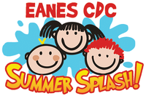  Monday: Buggy Walk  Tuesday: Soccer Shots  Wednesday: Art w/ Ms. Stelly  Thursday: Field Day  Friday: Water Day  Everyday: Gym and Thursdays w/ Ms. McIvor or Ms. Eggers

