Story Stretchers: Friendship
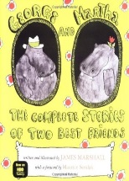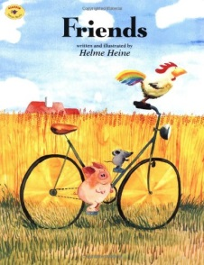
May 30th- June 2nd
Mrs. Pierre & Mrs. Miller
Classroom: Toddler I
Week 1 Topic: George and Martha & Friends
 |  | Monday | Tuesday | Wednesday | Thursday | Friday
Circle Time |  | Closed | Daily Calendar  Book: George and Martha | Daily Calendar  Book: George and Martha | Daily Calendar  Book: Friends | Daily Calendar  Book: Friends
Creative Arts |  | Closed | Create a Friendship Quilt | Create a Friendship Wreath | Create a Friendship Bracelet | Easel Painting with a Friend/Friends
Music & Movement |  | Closed | “The More We Get Together” Song | Special Music and Movement with Ms. Stelly | “My Friends Go Marching One by One” | “Where is _________?” Song
Outdoor Activity |  | Closed | Special Guest:  Soccer Shots | Nature Walk | Field Day | Water Play
 | Math & Science | Cooking:  Cherry Toaster Pastries
 | Sensory | Nature Items from Nature Walk  Magnifying Glasses
 | Dramatic Play | Post Office- Provide children with writing utensils, paper, envelopes, and stamps. Encourage children to write letter to friends or family members and stick them in the mailbox
 | Special Activities | Monday: Closed  Tuesday: Soccer Shots  Wednesday: Music w/ Ms. Stelly  Thursday: Field Day  Friday: Water Day  Everyday: Gym and Thursdays w/ Ms. McIvor or Ms. Eggers

