Story Stretchers: Friendship
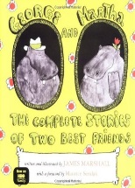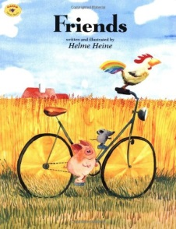
Lesson Plan
May 30th- June 2nd
Classroom:
Week 1 Topic: George and Martha & Friends
 |  | Monday | Tuesday | Wednesday | Thursday | Friday
Circle Time |  | Closed | Daily Calendar  Book: George and Martha | Daily Calendar  Book: George and Martha | Daily Calendar  Book: Friends | Daily Calendar  Book: Friends
Creative Arts |  | Closed | Dotting the letter “H” | Make a hippo face | Tissue paper pig | Painting a rooster
Music & Movement |  | Closed | “My friends go marching” song | Special Music and Movement with Ms. Stelly | “The more we get together” song | Freeze dance song
Outdoor Activity |  | Closed | Special Guest:  Soccer Shots | Nature Walk | Field Day | Water Play
 | Math & Science | Cooking:  Cherry Toaster Pastries
 | Sensory | Nature Items from Nature Walk  Magnifying Glasses
 | Dramatic Play | Farm animal puppets
 | Special Activities | 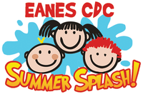  Monday: Closed  Tuesday: Soccer Shots  Wednesday: Music w/ Ms. Stelly  Thursday: Field Day  Friday: Water Day  Everyday: Gym and Thursdays w/ Ms. McIvor or Ms. Eggers

