Story Stretchers: Friendship
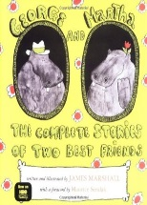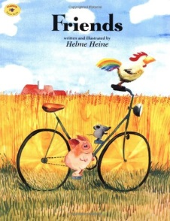
Lesson Plan
May 30th- June 2nd
Classroom: Infant
Week 1 Topic: George and Martha & Friends
 |  | Monday | Tuesday | Wednesday | Thursday | Friday
Circle Time |  | Closed | Good Morning song  Book: George and Martha | Good Morning song  Book: George and Martha | Good Morning song  Book: Friends | Good Morning song  Book: Friends
Creative Arts |  | Closed | Try to find stuffed bear around the room | Feel the texture of oatmeal | Frozen colored ice on paper | Sponge painting
Music & Movement |  | Closed | Imitates familiar sound patterns | Special Music and Movement with Ms. Stelly | Ring Around the Rosie Song | Dances with friends
Outdoor Activity |  | Closed | Special Guest:  Soccer Shots | Nature Walk | Sensory bag | Water Play
 | Math & Science | Color changing (food coloring and water)
 | Sensory | Nature Items from Nature Walk  Magnifying Glasses
 | Dramatic Play | Infants drop soft animals in to toy basket
 | Special Activities | Monday: Closed  Tuesday: Soccer Shots  Wednesday: Music w/ Ms. Stelly  Thursday: Field Day  Friday: Water Day  Everyday: Gym and Thursdays w/ Ms. McIvor or Ms. Eggers

