Story Stretchers: Friendship
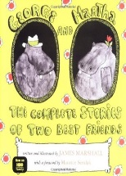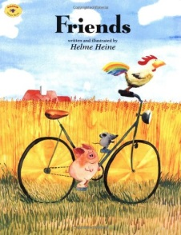
Lesson Plan
May 30th- June 2nd
Classroom: Preschool
Week 1 Topic: George and Martha & Friends
 |  | Monday | Tuesday | Wednesday |  | Thursday | Friday
Circle Time |  | Closed | Daily Calendar  Identify Class Friends  Book: George and Martha | Daily Calendar  Name Game  Book: George and Martha |  | Daily Calendar  Who Are You?  Book: Friends | Daily Calendar  What Can Friends do Together?  Book: Friends
Creative Arts |  | Closed | Friendship  Bracelets | Sponge  Painting  Easel Paint w/a friend |  | Nature  Collage  Easel Paint w/a friend | Sand  Painting
Music & Movement |  | Closed | Friendship  March  I Have Friend/  Yo Tengo Un Amigo | Special Music and Movement with  Ms. Stelly |  | Freeze Dance  Monkeys on the Bed  Boys vs Girls Dance | Bean Bag Boogie  Dancing with Streamers
Outdoor Activity |  | Closed | Special Guest:  Soccer Shots | Nature Walk  Colored Eggs Game |  | Field Day  What time is it  Mr. Crocodile? Game | Water Play  Follow our Friends
 | Math & Science | Counting Friends & Measuring Heights |  |  | Cooking:  Cherry Toaster Pastries
 | Sensory | Nature Items from Nature Walk  Magnifying Glasses
 | Dramatic Play | Friendship Picnic/Puppet Play
 | Special Activities | 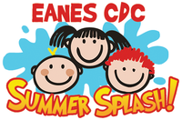  Monday: Closed  Tuesday: Soccer Shots  Wednesday: Music w/ Ms. Stelly  Thursday: Field Day  Friday: Water Day  Everyday: Gym and Thursdays w/ Ms. McIvor or Ms. Eggers

