Story Stretchers: Friendship
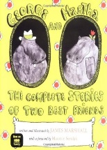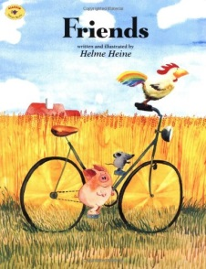
Lesson Plan
May 30th- June 2nd
Classroom: Pre-K
Week 1 Topic: George and Martha & Friends
 |  | Monday | Tuesday | Wednesday | Thursday | Friday
Circle Time |  | Closed | Daily Calendar  Book: George and Martha | Daily Calendar  Book: George and Martha | Daily Calendar  Book: Friends | Daily Calendar  Book: Friends
Creative Arts |  | Closed | My special hippo | Friendship Bracelets | Friendship  Play-dough | Rainbow Color Drawings
Music & Movement |  | Closed | Hippo Song:  Oh, I wish I was a hippo! | Special Music and Movement with Ms. Stelly | Friendship games | Name Game Song
Outdoor Activity |  | Closed | Special Guest:  Soccer Shots | Nature Walk | Frisbee Throwing | Water Play
 | Math & Science | Cooking:  Cherry Toaster Pastries
 | Sensory | Nature Items from Nature Walk  Magnifying Glasses
 | Dramatic Play | Children are encouraged to play and pretend in home center, as they form new friendship.
 | Special Activities | 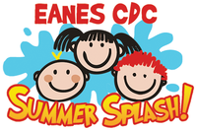  Monday: Closed  Tuesday: Soccer Shots  Wednesday: Music w/ Ms. Stelly  Thursday: Field Day  Friday: Water Day  Everyday: Gym and Thursdays w/ Ms. McIvor or Ms. Eggers

