Story Stretchers:
Tall and Funny Tales
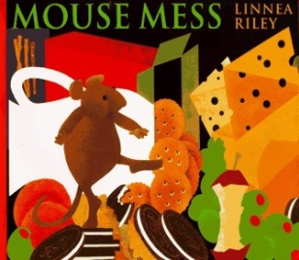
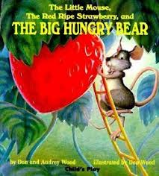
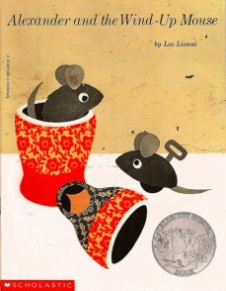
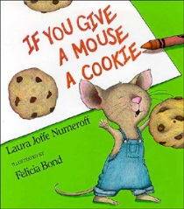

Lesson Plan

July 17th- July 21

Classroom: PreSchool

Week 7 Topic: & If You Give a Mouse a Cookie
 |  | Monday | Tuesday | Wednesday | Thursday | Friday
Circle Time |  | What do you know about mice?  Book: The Big Hungry Bear | What do mice eat?  Book: Mouse Mess | What do mice do in the day & night:  Book: Alexander and the Wind Up Mouse | Are the mice in our stories real or pretend?  Book: If You Give a Mouse a Cookie | Let’s make up a story about a mouse.  Book: If You Give a Mouse a Cookie
Creative Arts |  | Mouse Mask & Mouse Painting | Create a beaded a bell bracelet | Create a  Mouse House | Mouse Finger Puppet | Paint a Cookie & Add Sprinkles
Music & Movement |  | Small & Big  Body Movements to Music | Shake your beaded bracelet to the music | Special Music & Movement  w/Ms. Stelly | Instrument Play to Nursery Rhymes | Fun Friday Moving to the Oldies
Outdoor Activity |  | Hide & Seek Mice | Special Guest:  Soccer Shots | Build a  Mouse House | The Old Grey Cat is Sleeping  Game | Parachute Play  & Water Play
 | Math & Science | Special Snack  Little Nibbles (Pretzel Sticks, Cheese, Cereal, Raisins, Sunflower seeds)
 | Sensory | Mixed Dried Beans, Pouring/ Scooping Utensils
 | Dramatic Play | Mouse Headbands & Mouse Picnic
 | Special Activities | Tuesday: Soccer Shots  Wednesday: Music w/ Ms. Stelly  Thursday: Special Snack  Friday: Water Day  Everyday: Gym in the afternoon

