Story Stretchers:
Tall and Funny Tales
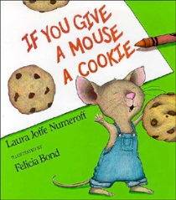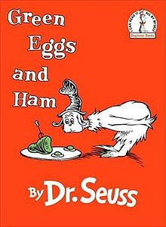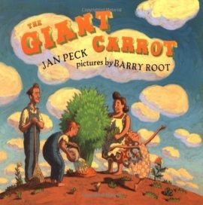
Lesson Plan
July 17th- July 21st
Classroom: Pre=K
Week 7 Topic: If You Give a Mouse a Cookie / The Giant Carrot
 |  | Monday | Tuesday | Wednesday |  | Thursday | Friday
Circle Time |  | Daily Calendar  Book:  If You Give a Mouse a Cookie | Daily Calendar  Book:  If You Give a Mouse a Cookie | Daily Calendar  Book:  Green Eggs and Ham |  | Daily Calendar  Book:  The Giant Carrot | Daily Calendar  Book:  The Giant Carrot
Creative Arts |  | Play dough Cookies | Paper Plate  Mouse | Green Slime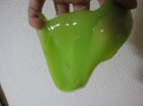 |  | Carrot  Collage | Bubble Wrap Painting  “Carrots in Garden”
Music & Movement |  | Yogu Poses 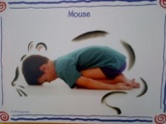 | Song:  Who stole the cookie from the cookie jar??? | Special Music and Movement with Ms. Stelly |  | Musical Chairs | Marching with Musical Instruments
Outdoor Activity |  | Bikes on Basketball Court | Special Guest:  Soccer Shots | Nature Walk |  | Parachute  Games | Water Play
 | Math & Science | Cooking:  Little Nibbles (Pretzel Sticks, Cereal, Raisins, Sunflower seeds) |  |  | Science:  Tasting Test: Cooked Carrot or Raw  Which is healthy?
 | Sensory | Colored Rice, Pouring/ Scooping Utensils, Scales
 | Dramatic Play | Children pretend to work and study at the “Library”
 | Special Activities | Monday:  Tuesday: Soccer Shots  Wednesday: Music w/ Ms. Stelly  Thursday: Cooking  Friday: Water Day  Everyday: Gym

