Story Stretchers:
Tall and Funny Tales
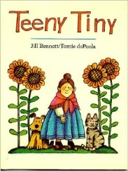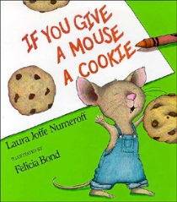
Lesson Plan
July 17th- July 21st
Classroom:
Week 7 Topic: Teeny Tiny & If You Give a Mouse a Cookie
 |  | Monday | Tuesday | Wednesday | Thursday | Friday
Circle Time |  | Daily Calendar  Book: Teeny Tiny | Daily Calendar  Book: Teeny Tiny | Daily Calendar  Book: Green Eggs and Ham | Daily Calendar  Book: If You Give a Mouse a Cookie | Daily Calendar  Book: If You Give a Mouse a Cookie
Creative Arts |  | Infants paint with a flower | Free art using green and yellow paint | Scribble finger paint using cool whip | Infants touch honey to explore the texture | Paint a mouse and cookies
Music & Movement |  | Sing: Itsy Bitsy Spider Song | Sing: You are my Sunshine | Special Music and Movement with Ms. Stelly | Crawl/Reach to the shaking rattle | Explore different sounds using a variety of musical instruments
Outdoor Activity |  | Yoga: Cow pose | Special Guest:  Soccer Shots | Nature Walk | Field Day | Water Play
 | Math & Science | Cooking:  Little Nibbles (Pretzel Sticks, Cereal, Raisins, Sunflower seeds)
 | Sensory | Colored Rice, Pouring/ Scooping Utensils, Scales
 | Dramatic Play | Pretend to talk on the phone/ Have fun with hats on your head
 | Special Activities | Monday:  Tuesday: Soccer Shots  Wednesday: Music w/ Ms. Stelly  Friday: Water Day  Everyday: Gym

